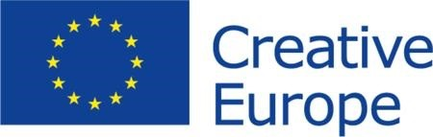
Date: 2/3/2021

Partner search form
For Creative Europe project applications

Call | Support to European Cooperation Projects 2021
Strand or category | Small Scale Cooperation Projects

Cultural operator – who are you?
Name of organisation | Association of Citizens "Kruna"
Country | Republic of Serbia
Organisation website | www.kruna.org
Contact person | Mrs. Jelena Popović Đorđević, jelena.popovic.pr@gmail.com
Organisation type | civil society organization
Scale of the organization | 1-3 employers
PIC number | 895916348
Aims and activities of the organisation | The Association of Citizens "Kruna" is non-governmental and non-profit association. Main focus of the organization is street art. Areas of activities are the research and reform of art, science and culture, affirmation of young artists, research and development of alternative art forms and practices, as well as the cooperation with cultural, art and scientific institutions. As an association we are dedicated to document, popularize and preserve street art trough events and digitization projects. We have organized exhibitions, workshops for senior citizens, street art events, panel discussions and also in 2020. we have  published first Belgrade street art exhibition in Virtual Reality.
Role of the organisation in the project | Project partner.
Previous EU grants received | N/A

Proposed Creative Europe project – to which project are you looking for partners?
Sector or field | Street art and cultural heritage, digitization
Description or summary of the proposed project | We are interested to join projects where our expertise and knowledge will be applicable, specifically in the domain of  street art.
Partners currently involved in the project | During the last application process we have made strong partnerships with street art organizations from Austria, Slovenia and Croatia. These organizations are open to join us  in future projects as partners.

Partners searched – which type of partner are you looking for?
From country or region | Open to all
Preferred field of expertise | Street art
Please get in contact no later than | On going

Projects searched – are you interested in participating in other EU projects as a partner?
Yes / no | Yes

* By answering “yes” you confirm that the information provided can be shared publicly by the Creative Europe Desks in the countries participating in the Creative Europe programme, in order to support your search for partners.

Which kind of projects are you looking for? | cultural heritage, education, diversity, residencies, digitization

Publication of partner search
This partner search can be published?* | Yes

